**Data Science**

**1. An Introduction to Data Cleaning: Why It Matters**

Imagine you need to find a pen in your room, but your room is messy—clothes are on the floor, books are scattered, and everything is in disarray. It takes a long time to find the pen, and you might even give up. Data cleaning is similar: when data is messy—full of errors, duplicates, or missing values—finding the right insights becomes difficult and unreliable.

**Why is Data Cleaning Important?**  
If you don’t clean your data, you won’t get good results, just like you can’t find your pen in a messy room. By cleaning, it helps our datasets for better analysis.

**Simple Steps to Clean Data**:

1. **Remove duplicates**: Like removing extra clutter, get rid of repeated data entries.
   * **Technique**: Use functions like drop_duplicates() in Python’s Pandas library.
2. **Fill missing values**: Complete any missing data, like making sure every item has its place. For instance, if some sales prices are missing, you can fill them with the average or median value.
   * **Technique**: Use methods like mean/median imputation with fillna() in Pandas.
3. **Correct formatting**: Ensure data is in a standard, readable format, just like neatly organizing your items. For example, dates should all be in the same format (like DD/MM/YYYY).
   * **Technique**: Standardize formats using string operations or functions like to_datetime() for dates.
4. **Handle outliers**: Remove or adjust data points that are far outside the normal range, much like discarding items that don’t belong in the room.
   * **Technique**: Use Z-score or IQR (Interquartile Range) methods to detect and handle outliers.

**2. The Basics of Machine Learning: Types and Applications**

Imagine you have a newborn baby. As the baby grows, you teach them how to recognize objects, say words, and even walk. When you show them a ball and say “ball,” they learn to associate that word with the object. This process of learning from experience is similar to how machine learning (ML) works—it's about teaching computers to learn from data and improve their performance over time without being explicitly programmed.

**Why is Machine Learning Important?**  
Machine learning allows computers to analyze vast amounts of data, recognize patterns, and make decisions or predictions based on that data. This capability is crucial in today’s data-driven world, where we need quick and accurate insights.

**Types of Machine Learning**

1. **Supervised Learning**
   * **Description**: In supervised learning, we provide the computer with both inputs and outputs for analysis, much like guiding your baby to identify different objects and telling them the names of each one. The computer uses this labeled data to learn and create a model. Once trained, it can predict outcomes for new, unseen data.
   * 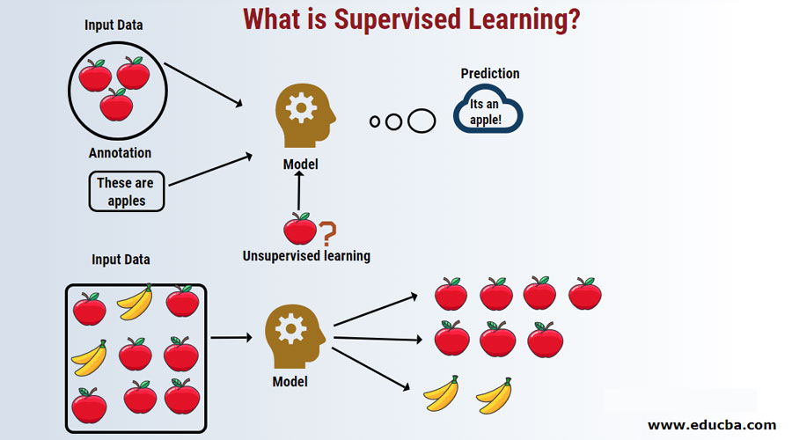**Example**: Imagine teaching a computer to identify fruits based on pictures. You show it many pictures of apples and label each one as “apple.” By providing both the image (input) and the label (output), the computer learns to recognize the features that define an apple. Later, when it sees a new picture of an apple, it can confidently predict that it is indeed an apple based on what it has learned.

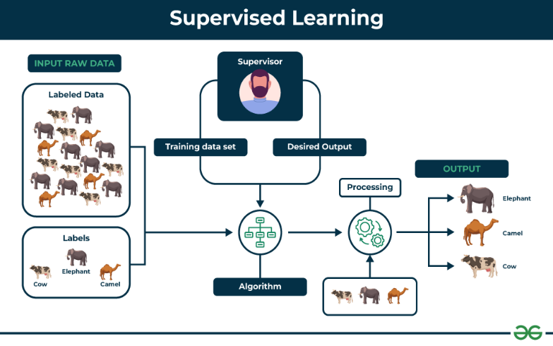

1. **Unsupervised Learning**
   * **Description**: In unsupervised learning, we provide the computer with inputs but no labels, similar to letting a baby explore a toy box without telling them what each toy is. The computer analyzes the data and finds patterns or groups on its own.
   * 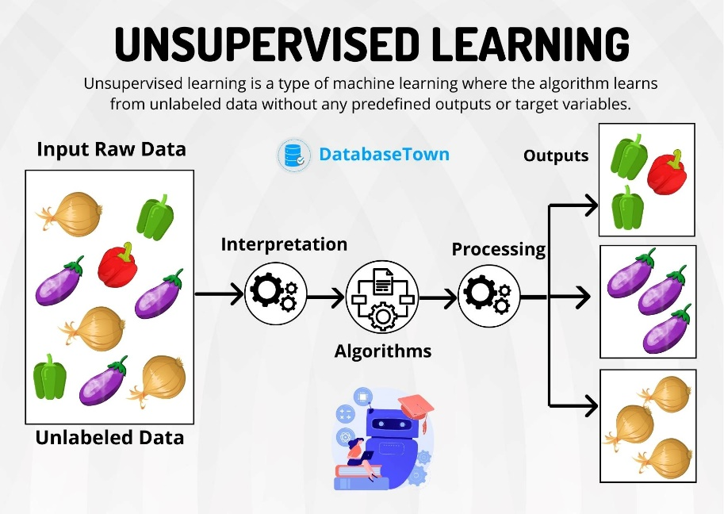**Example**: Imagine you have a collection of animal pictures but no labels to identify them. The computer examines these images and might group all the cats together and all the dogs together based on their features, such as fur color or shape, without knowing what each animal is called.
2. **Reinforcement Learning**
   * **Description**: Reinforcement learning involves teaching the computer through rewards and penalties, much like teaching your baby to walk. When they take a step and maintain balance, you cheer them on; when they face difficulties, you guide them back up. The computer learns to take actions that maximize rewards over time.
   * **Example**: Think of teaching a baby to organize their toys. When they put away their toys, you praise them (reward), encouraging them to do it more often. If they leave toys scattered around, you may express disappointment or angry (penalty). Through this positive reinforcement, the child learns that organizing leads to praise, motivating them to repeat the behavior.

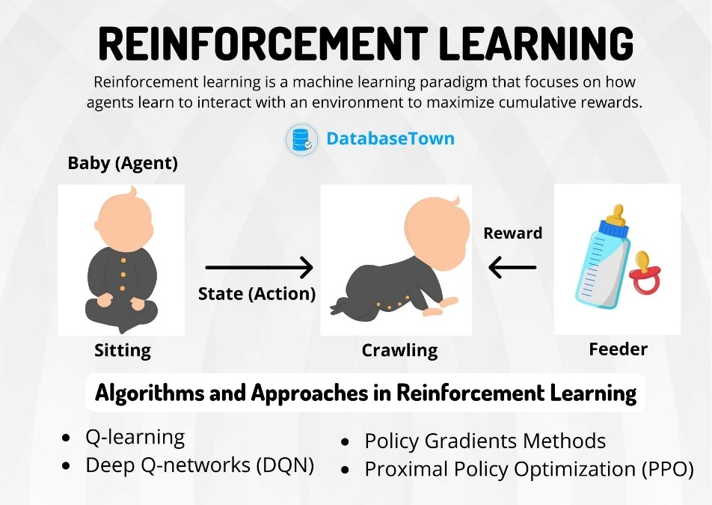

**Applications of Machine Learning**

1. **Spam Detection**
   * **Description**: Just like sorting through mail to find important letters, machine learning helps email services identify and filter out spam.
   * 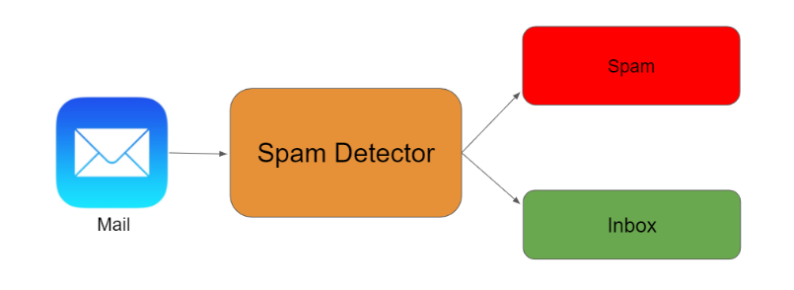**Example**: When you receive an email that looks like a scam, machine learning algorithms learn to recognize similar patterns in the future and move those emails to your spam folder.
2. **Movie Recommendations**
   * **Description**: Similar to asking a friend for movie suggestions based on what you like, machine learning powers recommendation systems on streaming platforms.
   * 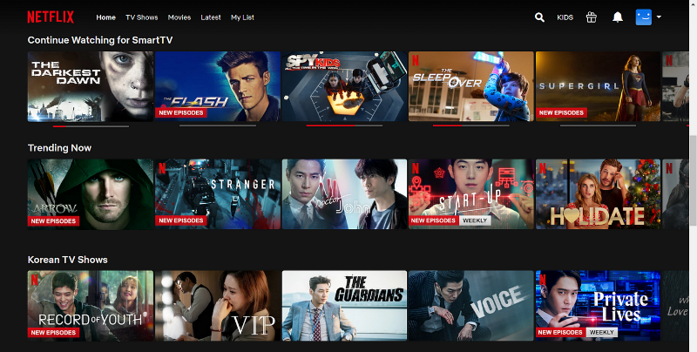**Example**: If you enjoy superhero movies, the platform uses ML to suggest other superhero movies you might like based on your viewing history.
3. **Voice Assistants**
   * **Description**: Just like teaching your baby to respond to their name, voice assistants learn to recognize and respond to your voice commands.
   * **Example**: Saying “Play my favorite song” prompts the assistant to find and play the song based on what it has learned from your previous requests.
4. **Predictive Text**
   * **Description**: Similar to how you might guess what a baby is trying to say based on their babbling, smartphones use machine learning to predict what you want to type next.
   * 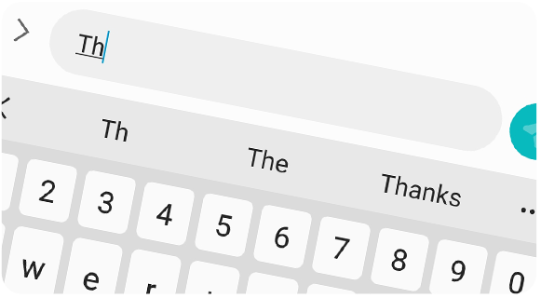**Example**: When you start typing “How are,” your phone suggests “you?” based on what it has learned from your texting habits.
5. **Image Recognition**
   * **Description**: Just as a baby learns to recognize faces, machine learning helps computers identify objects in photos.
   * 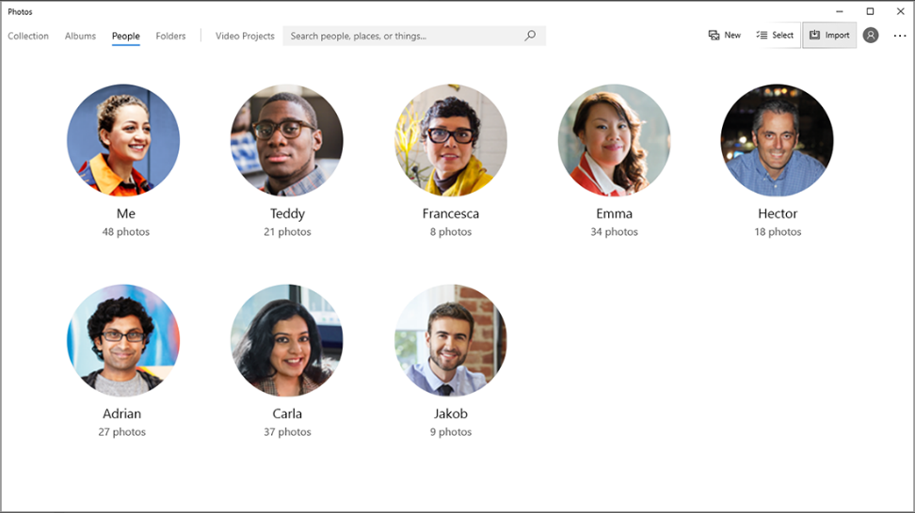**Example**: When you upload a photo, a social media platform can automatically tag friends by recognizing their faces in the image.

**3. Understanding Data Visualization: Best Practices and Tools**

Imagine you want to explain to a friend how many different fruits you have. Instead of just listing them, you show a colorful picture of all the fruits together. This is the magic of data visualization—it helps us understand complex information quickly by using visuals like charts and graphs.

**Why is Data Visualization Important?**

Data visualization helps us see trends and patterns in large sets of data. Just like how seeing a picture makes it easier to understand, good visualizations help people make smart decisions based on what the data shows.

**Best Practices in Data Visualization:**

1. **Keep it Simple**
   * **Description**: Just like teaching a child their first colors with basic shapes, aim for clear visuals. Avoid too much clutter.
   * 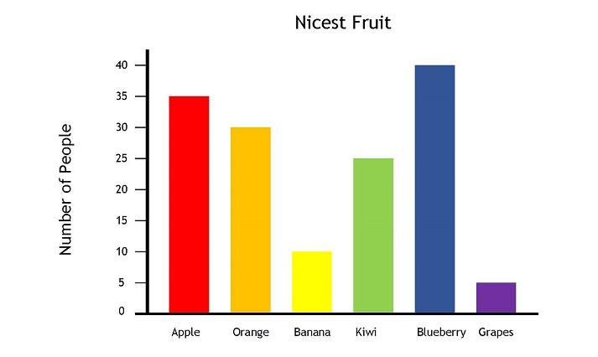**Example**: Instead of a complicated pie chart, use a simple bar chart to compare different fruits. It’s easier to see which fruit you have the most of.
2. **Use the Right Chart Type**
   * **Description**: Picking the right tool for a job is important. A hammer for nails, a screwdriver for screws, and the right chart for your data!
   * **Example**: Use a line graph to show how a baby grows over months. A line chart clearly shows the baby's height increase month by month.

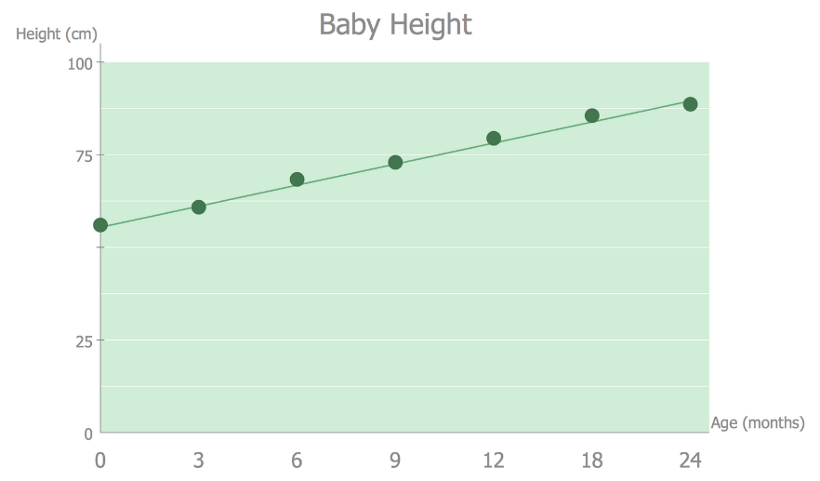

1. **Label Clearly**
   * **Description**: Just like putting names on toy boxes helps a child find their toys, clear labels on charts help viewers know what they’re looking at.
   * **Example**: If you show how many books were read each month, label the x-axis as "Months" and the y-axis as "Books Read."
2. **Use Color Wisely**
   * **Description**: Color can be fun, but using too many can be confusing. Choose easy-to-tell-apart colors.
   * 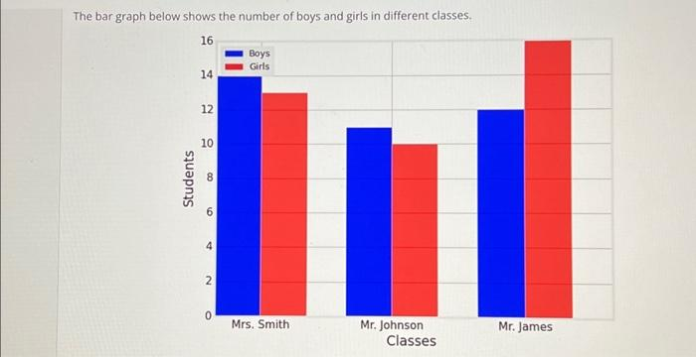**Example**: In a bar chart showing boys and girls in a class, use blue for boys and pink for girls to help viewers quickly see the difference.
3. **Tell a Story**
   * **Description**: Just like telling a bedtime story helps children understand the plot, your visuals should guide viewers through the data.
   * **Example**: Start with a main chart that shows the key point, then follow with other charts that provide more details, helping viewers understand the complete picture.

**Tools for Data Visualization:**

1. **Microsoft Power BI**
   * **Description**: Power BI helps businesses visualize and share data, like how families share stories at dinner.
   * **Example**: A sales team can create reports to see which products are selling best throughout the year.
2. **Tableau**
   * **Description**: Tableau is a fun tool for making data visuals. You can easily create interactive charts by dragging and dropping.
   * **Example**: A teacher can use Tableau to show student performance with colorful graphs of test scores and attendance.
3. **Excel**
   * **Description**: Excel is a classic tool for making simple charts, like a child's first drawing on paper.
   * **Example**: A student can track how many hours they studied each week and create a simple bar chart to see their progress.
     + **Deepak Kumar Mohanty**

**Thank You**